Robotics Process Automation Design and Development (UiPath) – BCG701 Lab
Experiment No: 7
Title: Develop Excel automation in UiPath StudioX to demonstrate the following activities: Use Excel File, Insert Sheet, Rename Sheet, Duplicate Sheet, Delete Sheet, For Each Excel Sheet, Insert Column, Text To Columns, Delete Column.

Aim: To develop an automation in UiPath StudioX that demonstrates Excel file automation by performing operations such as:
- Use Excel File
- Insert Sheet
- Rename Sheet
- Duplicate Sheet
- Delete Sheet
- For Each Excel Sheet
- Insert Column
- Text To Columns
- Delete Column

Theory:
- Use Excel File: The Use Excel File activity found under Resources allows you to create or open an Excel file to utilize the file’s data in your automation. This is the foundation for the Excel automation and serves as the parent activity integrating StudioX with Excel. For example, copying and pasting, sorting, filtering, inserting, and deleting data activities can be added as child activities within the Use Excel file activity.
- Insert Sheet: The Insert Sheet activity allows you to add an empty sheet to a workbook.
- Rename Sheet: The Rename Sheet activity changes the name of an existing sheet in a workbook.
- Duplicate Sheet: The Duplicate Sheet activity creates a copy of a chosen sheet within the same workbook.
- Delete Sheet: The Delete Sheet activity deletes a specified sheet from a workbook.
- For Each Excel Sheet: The For Each Excel Sheet activity allows you to execute one or more activities against each sheet within the same workbook.
- Insert Column: The Insert Column activity adds a newly defined column to a range, sheet, or table in a worksheet.
- Text To Columns: The Text To Columns activity allows you to split the text in a given cell, sheet, or range to separate columns.
- Delete Column: The Delete Column activity allows you to delete a column in a sheet, range, or table from a workbook.
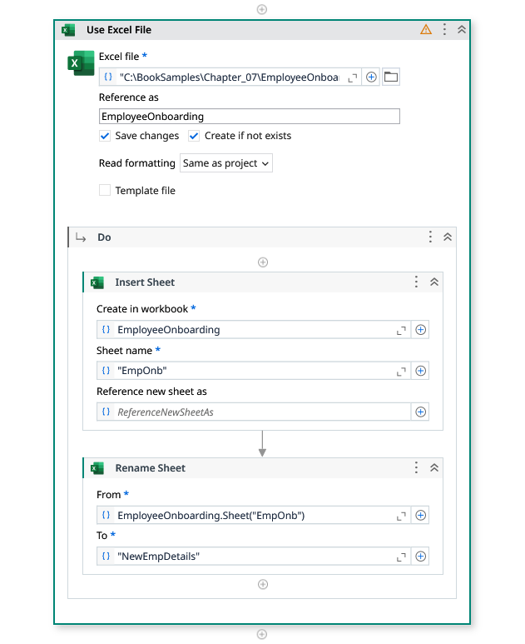
Conduction:
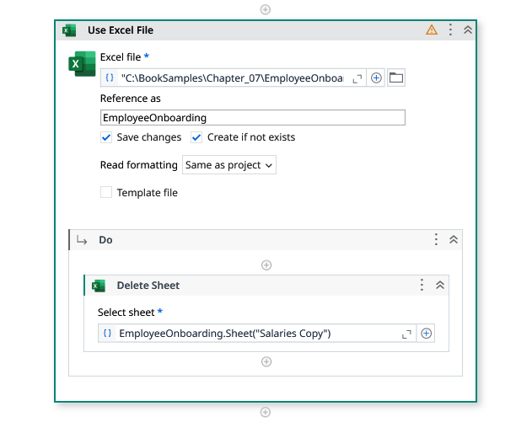
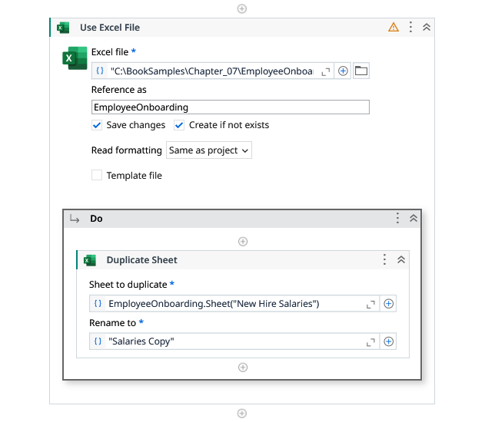

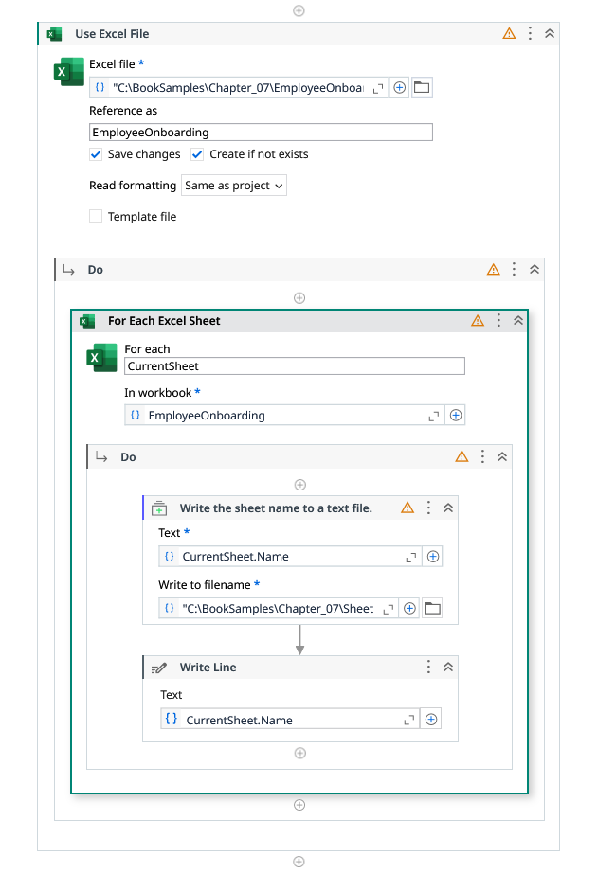
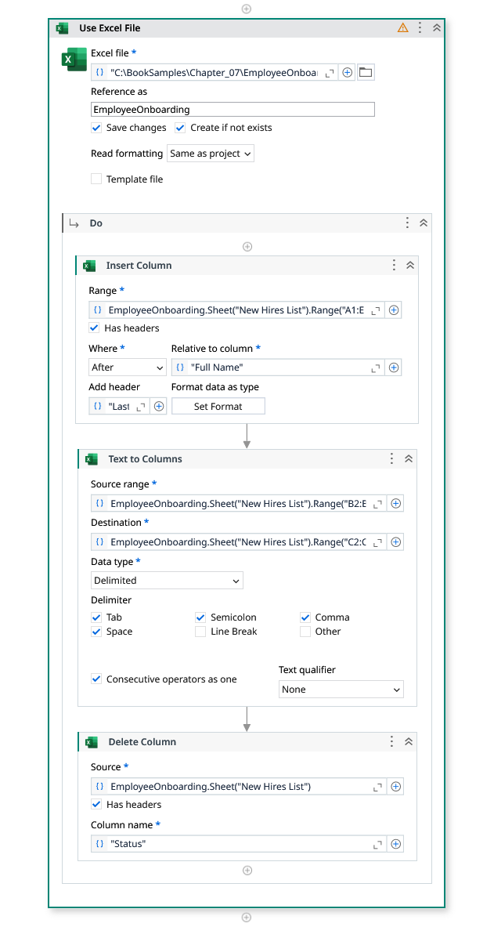

Output:
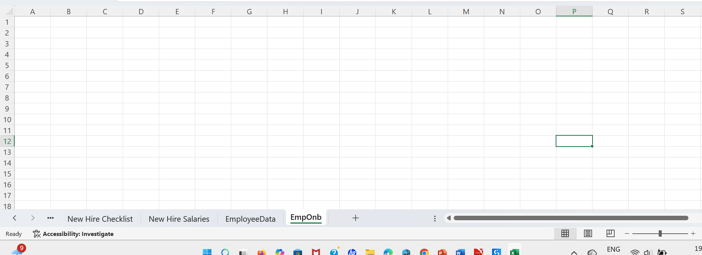

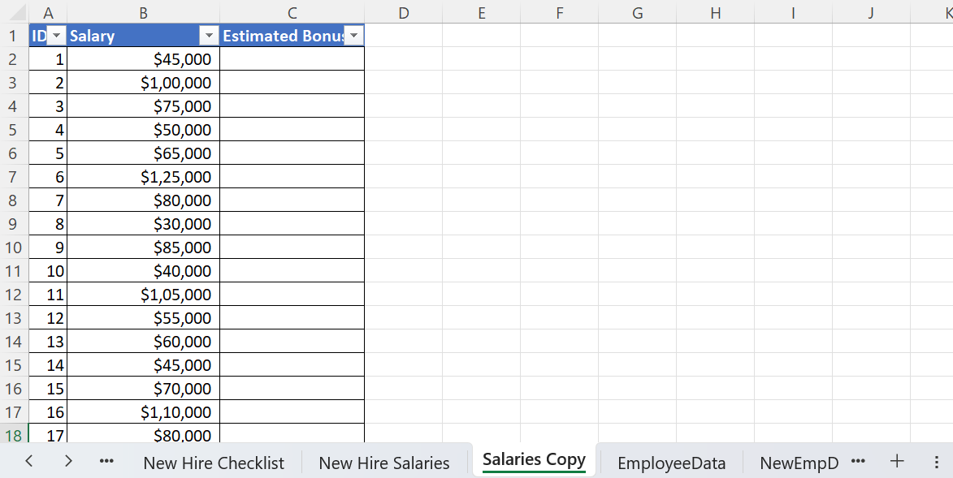
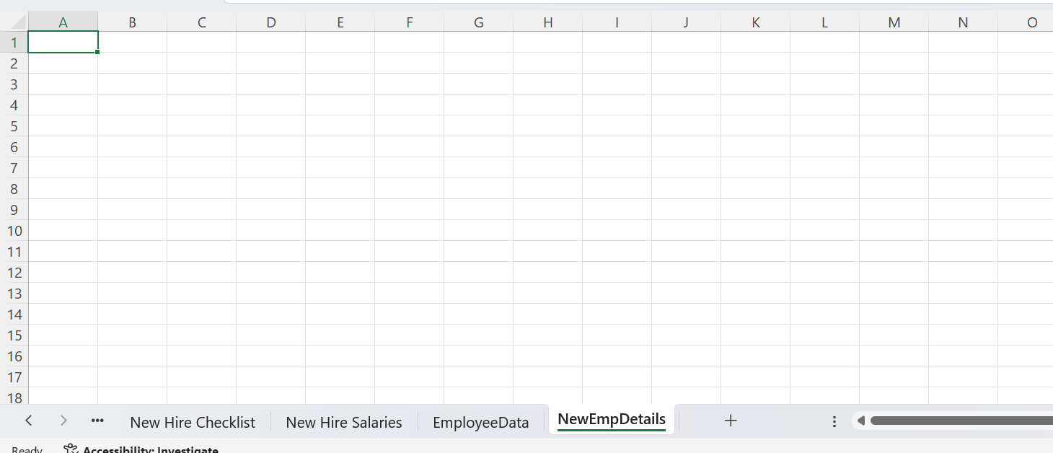

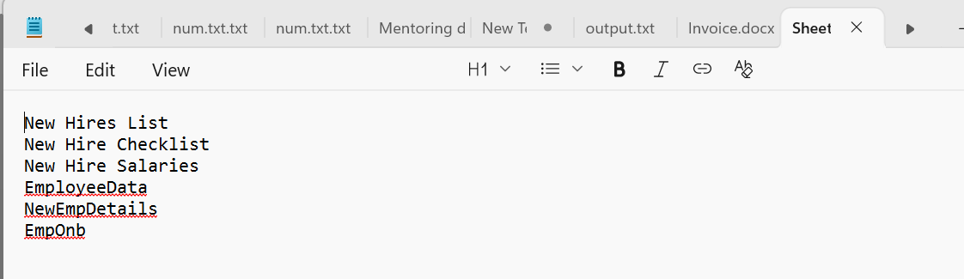
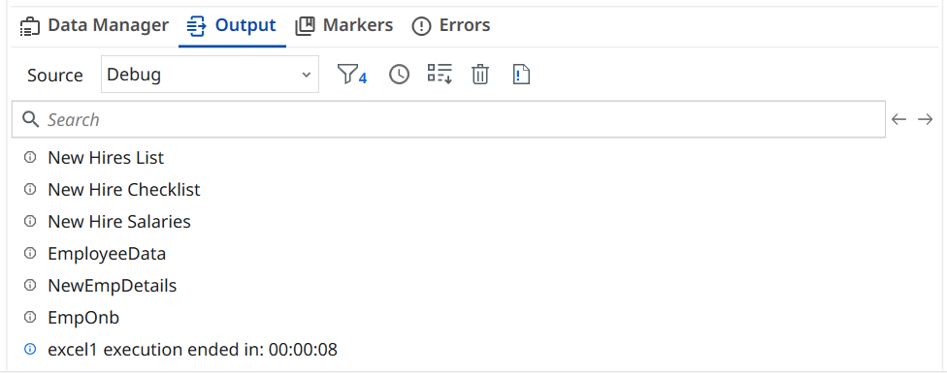
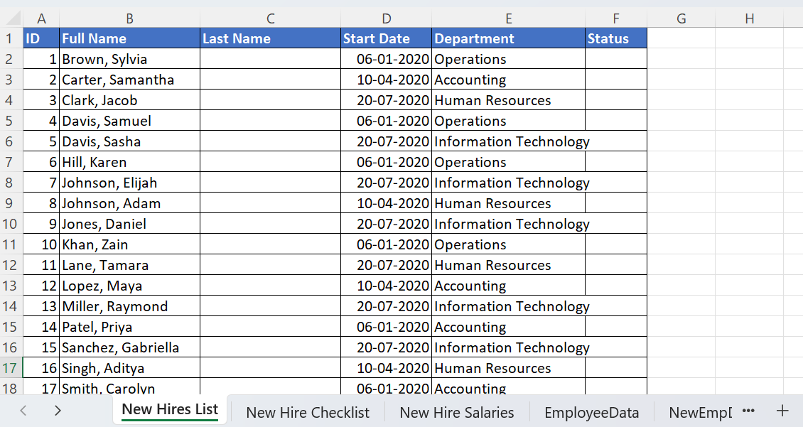

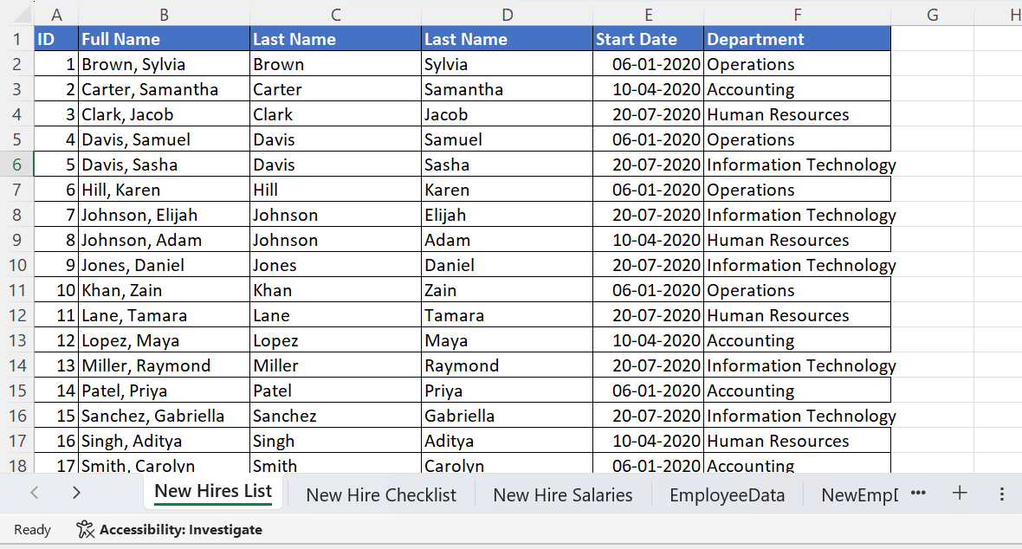
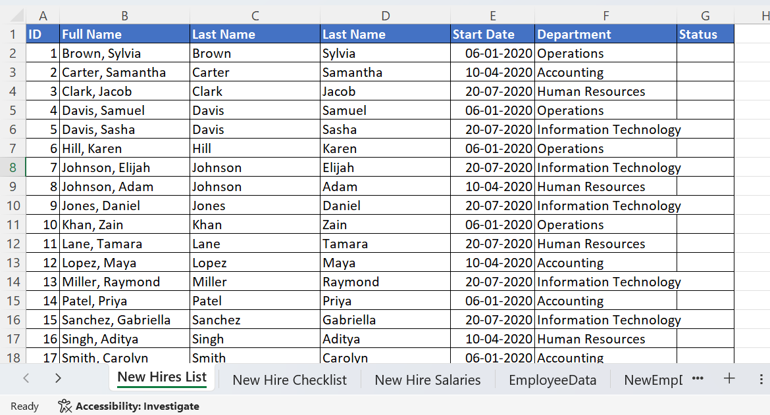

Observation and Results:
The following activities were successfully demonstrated in UiPath StudioX:
- Use Excel File
- Insert Sheet
- Rename Sheet
- Duplicate Sheet
- Delete Sheet
- For Each Excel Sheet
- Insert Column
- Text To Columns
- Delete Column
The output for the above-mentioned activities is verified.

Evaluation:
Evaluation Parameters | Maximum Marks | Obtained Marks
Conduction | 8
Record Writing | 4
Viva | 3
Total | 15

Signature of the Faculty in-charge with date:

